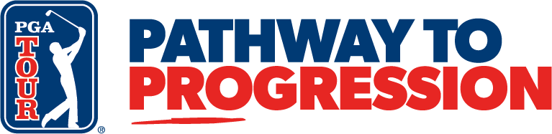

FOR RELEASE: February 11, 2026
CONTACT: Justin Johns, PGA TOUR, justinjohns@pgatourhq.com
Pathway to Progression announces 2026 Underclass Elite Ranking
Unveils new Underclass Elite Showcase for top 15 in final ranking

PONTE VEDRA BEACH, Florida – The PGA TOUR today unveiled the updated standings of the Underclass Elite Ranking, with University of Nebraska junior Rudy Sautron in the top spot.

The Pathway to Progression Underclass Elite Ranking is a new enhancement within the PGA TOUR Player Development program, designed to evaluate and recognize the top emerging collegiate golfers, highlighting a diverse group of elite underclass athletes – predominantly African American players – from across the country. It supports players who are in their freshman, sophomore and junior years.

The program, which runs through the completion of the NCAA conference championships, provides early access to developmental and competitive resources, helping to build a stronger, more prepared pipeline of talent for professional golf, with top-ranked players receiving invites to high-level amateur events and performance experiences.

“The Underclass Elite Ranking is a critical lever in strengthening the Pathway to Progression program and provides further affirmation of the TOUR’s commitment to broadening representation across professional golf,” said Kenyatta Ramsey, PGA TOUR Vice President, Player Development.

Sautron has maintained the top spot since the initial ranking was released in November of 2025. Argyle Downes from Rutgers University is currently ranked second, with Sascha Robinson from Florida A&M University in third. Roman Solomon from the University of South Florida and Jayden Lizama from Gonzaga University – both members of the Junior Development Program in high school – round out the top five, respectively.

The top player in the final ranking receives an exemption into The Monroe Invitational, an elite summer amateur event held annually at Monroe Golf Club in Pittsford, New York. The second- and third-ranked players in the final standings both receive exemptions into the Thunderbolt amateur tournament, with the top 15 players receiving invitations to participate in the Pathway to Progression Underclass Elite Showcase.

The Underclass Elite Showcase will comprise of the top 15 players in the Underclass Elite Ranking, plus three exemptions to players registered in the rankings who participated in the Pathway to Progression Junior Development Program. The 54-hole event will be played July 13-16, 2026 at TPC Deere Run in Silvis, Illinois. The top five finishers of the event will receive an invitation to the Underclass Elite Performance Center Experience at the TPC Sawgrass Performance Center in Ponte Vedra Beach, Florida.

The Underclass Elite Ranking utilizes the CLIPPD platform to rank eligible golfers via the Average Strokes Gained formula.

###

About PGA TOUR
By showcasing golf’s greatest players, the PGA TOUR engages, inspires and positively impacts our fans, partners and communities worldwide.

The PGA TOUR, headquartered in Ponte Vedra Beach, Florida, co-sanctions events on the PGA TOUR, PGA TOUR Champions, Korn Ferry Tour, PGA TOUR Americas and administers PGA TOUR Q-School presented by Korn Ferry and PGA TOUR University. PGA TOUR members represent the world’s best players, hailing from 28 countries and territories. Showcasing the biggest moments in the sport with history and legacy on the line, the PGA TOUR operates PGA TOUR Studios–a state-of-the-art production studio redefining golf content for fans worldwide—and has long-term domestic distribution partnerships for broadcast coverage on CBS, NBC and Golf Channel, with video streaming service on ESPN+ and additional coverage on multiple Free Ad-Supported Television (FAST) channels. Internationally, the PGA TOUR Studios-produced World Feed is available across 200+ countries and territories in 30 languages via 39 broadcast and digital partners. To date, events across all Tours have generated more than $4 billion in charitable giving. Fans can follow the PGA TOUR at PGATOUR.COM, on the app and in multiple languages across their favorite social media pages.

About the Pathway to Progression
Formerly announced in March 2023, the PGA TOUR’s Pathway to Progression player development program is an initiative designed to identify and support underrepresented golf talent across the junior, collegiate and professional levels. The program provides access, resources, and competitive opportunities to help players advance through the amateur ranks. Through strategic alignments and partnerships, Pathway to Progression aims to build a stronger, more diverse pipeline of future TOUR professionals.

